34.21: 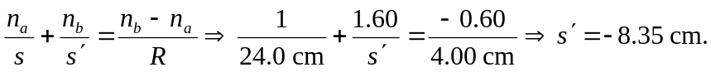
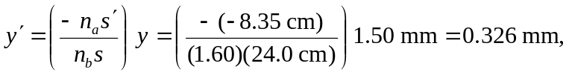so the image height is 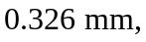and is erect.

